Community Interactions and the Willow Leaf Beetle

The willow leaf beetle, Chrysomela aeneicollis, is an insect that lives in cool climates in western North America, including high in the Sierra Nevada mountain range. They have a fairly simple food web that includes their primary food source, the Sierra Willow (Salix orestera) and a small number of predators including crawling predators such as a predatory red mite, ants belonging to the genera Formica and Camponotus, a syrphid fly (Parasyrphus melanderi), and a solitary wasp (Symmorphus cristatus).

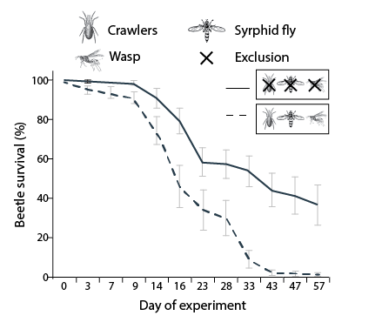
In 2008, a group of researchers examined the how changes in predator diversity affect herbivorous beetle, and as a result, how they alter other members of the ecological community. The researchers removed predators in the simple food web, and observed changes to herbivore biomass and survivorship, as well as the amount of plant biomass consumed.

The figure on the right shows the time course of willow leaf beetle (Chrysomela aeneicollis) survival (percentage of initial egg number) from day 0 (experimental setup) to day 57 (sampling and counting of hatched beetle adults): comparison of treatments with all three predators (dashed line) and with total predator exclusion (solid line). The x-axis depicts data on sampling dates rather than over a continuous time course.

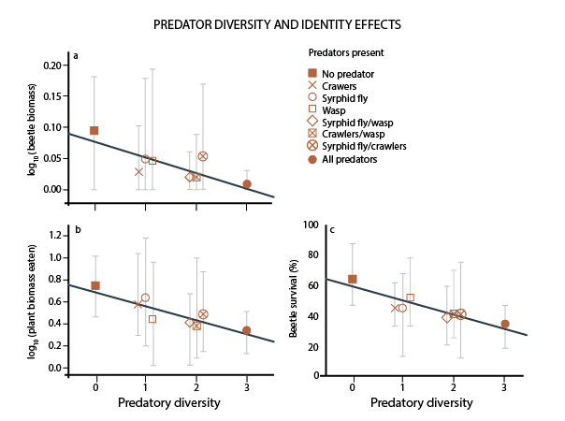
The figure on the left shows the predator diversity (0–3 species) effects on (a) log10-transformed beetle biomass (originally measured in grams); (b) the amount of log10-transformed plant biomass consumed by the beetles (originally measured in grams); and (c) the average survivorship of beetle individuals at the end of the experiment. Symbols show treatment means; whiskers indicate the treatment minima and maxima.

- Examine the figure showing beetle survivorship with and without predators. Describe, using data, the impact of predators on beetle survival.

- Explain the relationship between the number of predators present and the survivorship of beetles.

- A food chain is a simple biological model showing trophic transfers. Create a simple food chain to model two trophic transfers that includes a willow leaf beetle. Be sure to label the species that is the producer, the primary consumer, and a secondary consumer.

- Explain how the total biomass of willow leaf beetles affects the amount of predators the ecosystem can support. What biological concept does this demonstrate?

Images adapted from Otto, Sonia B. et al (2008) Predator Diversity And Identity Drive Interaction Strength And Trophic Cascades In A Food Web. Ecology, 89(1), 2008, pp. 134–144

