Population Shifts and a Changing Climate
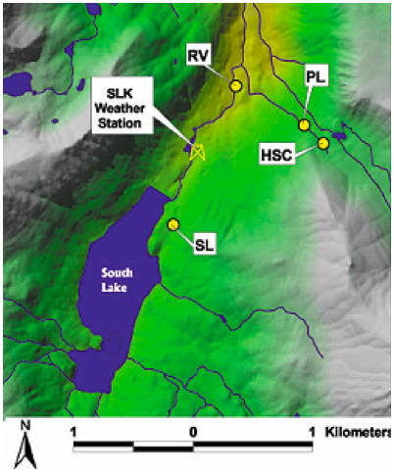
In 1988, a total of 518 adult beetles were collected at four different locations near the South Lake weather station. In 1996, the researchers returned and collected 366 adult beetles from those same locations. These are high-altitude in the eastern Sierra Nevada region of Bishop Creek: RV, Rainbow Village, 2878 m; SL, South Lake, 2995 m; PL, Pipeline, 3131 m; and HSC, High Stream Crossing, 3203 m.

The allele frequencies are shown below (the locations from left to right are RV, SL, PL, HSC). The trend clearly shows that the PGI-1 allele frequency increased while the PGI-4 decreased.

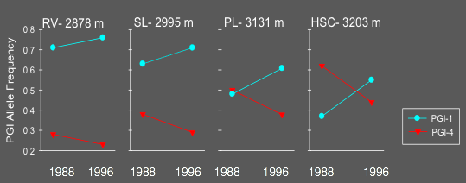

The researchers found an 11% directional change in allele frequency for PGI.
Genotype | 1-1 | 1-4 | 4-4
Initial frequency, 1988 | 0.31 | 0.42 | 0.27
Final frequency, 1996 | 0.40 | 0.50 | 0.10

The results from this study published by Rank and Dahlhoff (2002) suggest that differing thermal stress responses are responsible for the shifts in PGI allele frequency. After several years of cool, wet conditions in the 1990s (which they noted were quite different from the hot, dry drought conditions throughout the 1980s) PGI-1 increased in frequency at all study sites in Bishop Creek. In the lab, they also found that survival after nighttime exposure to subzero temperatures partially depended on the beetle’s PGI genotype. The data suggests that the cooler climate of the mid-1990s may have caused an increase in frequency of the PGI-1 allele due to a more robust physiological response to cold by PGI 1–1 and 1–4 genotypes.

According to the 2018 publication “Climate Change in the Sierra Nevada: California’s Water Future,” by Hall et al. from the UCLA Center for Climate Science, at the elevations where the willow beetles are found, temperatures could rise from 7 to 10 degrees Fahrenheit by the end of this century.

Use the Information above to answer the following questions:
- In the discussion of their paper, Rank and Dahlhoff state that they suspect that selection of “...the PGI-1 allele may have been even greater at high elevations than at low ones, because those populations experienced the coldest nighttime temperatures.” Explain how their suspicions relate to the different thermal stress responses of the PGI-1 and PGI-4 alleles.

- Consider the UCLA Center for Climate Science’s prediction for climate change over the remainder of the 20th century.
  - Describe how beetles with the 1-1 and 4-4 each respond to thermal stress.

  - Predict how the allele frequencies may shift as the climate warms. Justify your prediction.

  - Construct a graph that represents how you think allele frequencies may change over the next few decades.

